## widget_instances table

## Fields

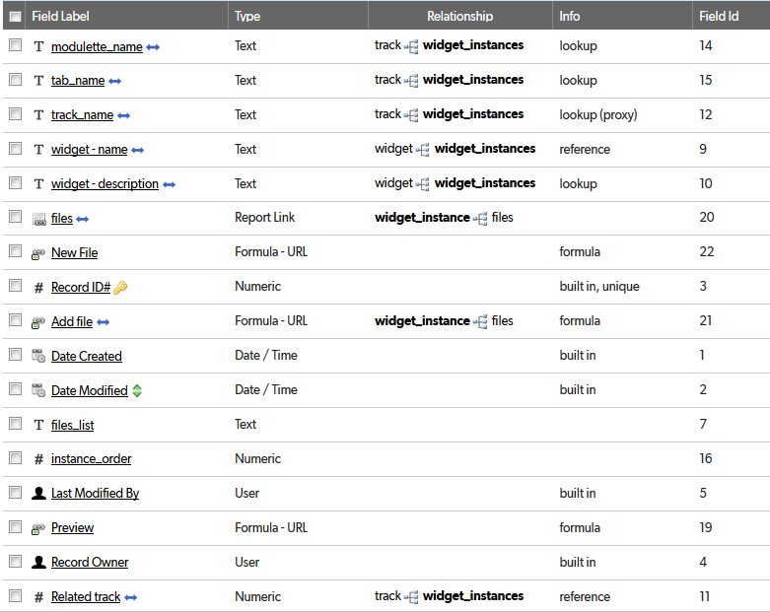

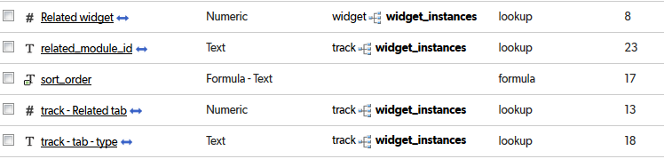

## Relationships

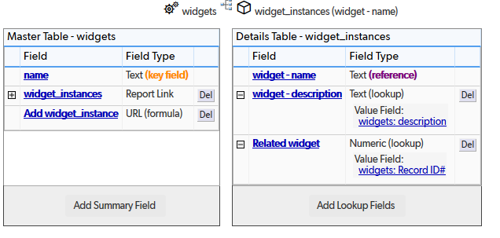

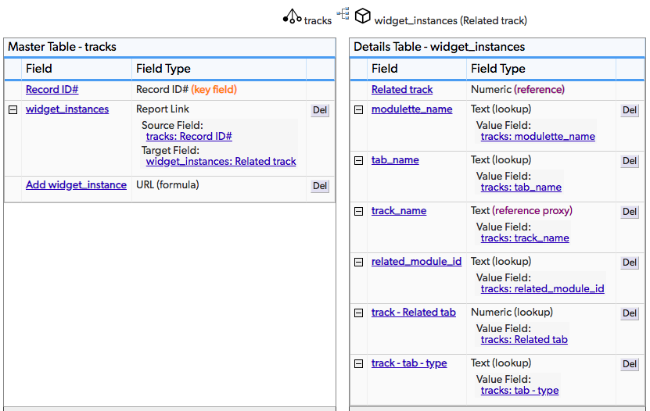

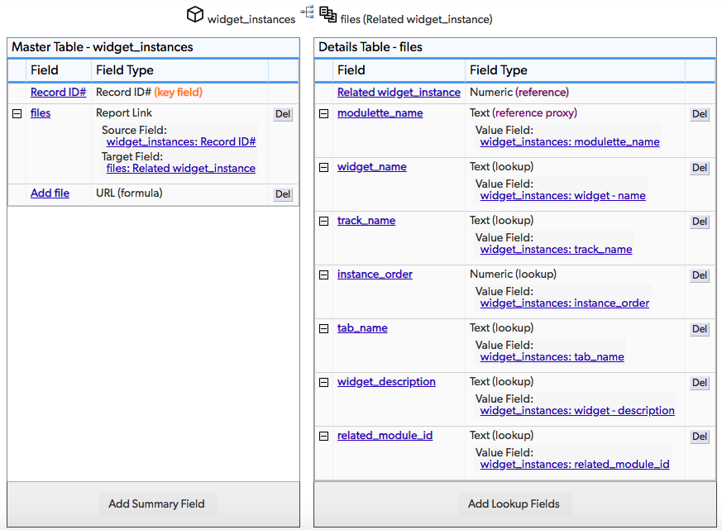

## Field settings

Note: Built-in fields use the default settings

modulette_name 4

tab_name 5

track_name 6

widget - name 7

widget - description 9

files 10

New File 11

Add file 12

files_list 14

instance_order 15

Preview 16

Related track 18

Related widget 20

related_module_id 23

sort_order 24

track - Related tab 25

track - tab - type 27

# modulette_name

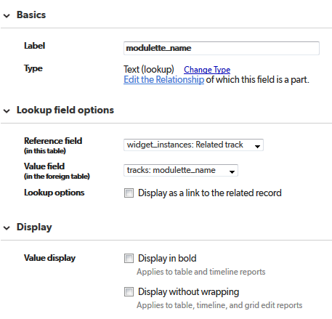

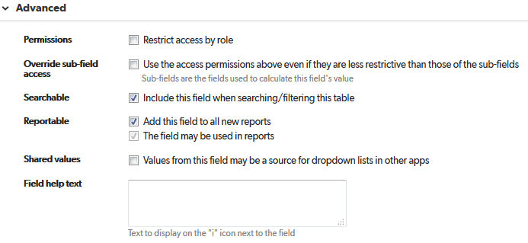

# tab_name

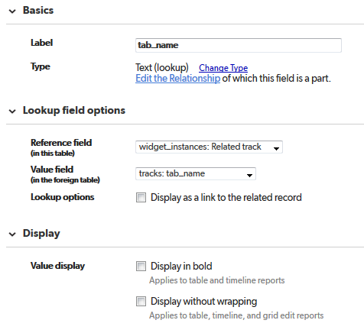

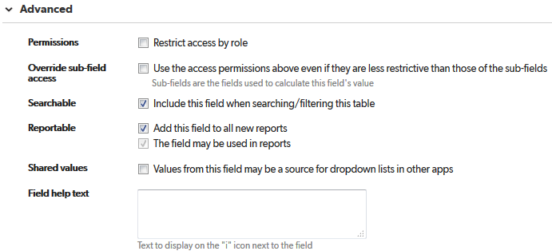

# track_name

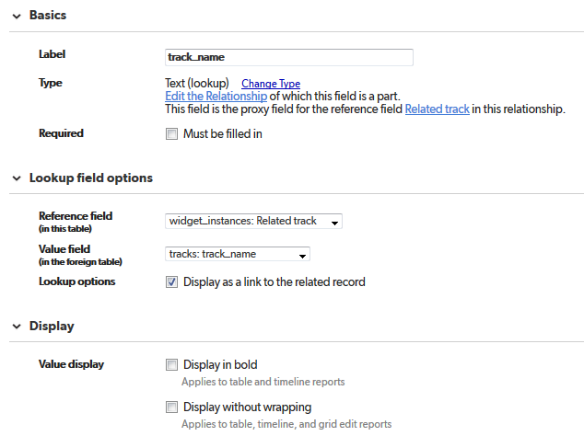

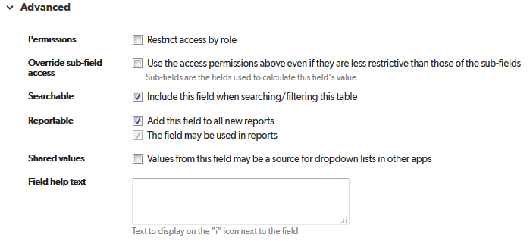

# widget – name

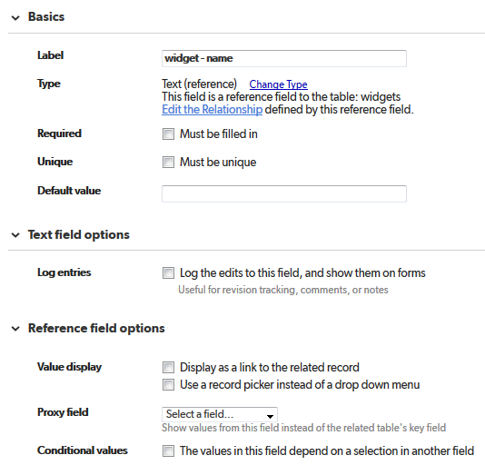

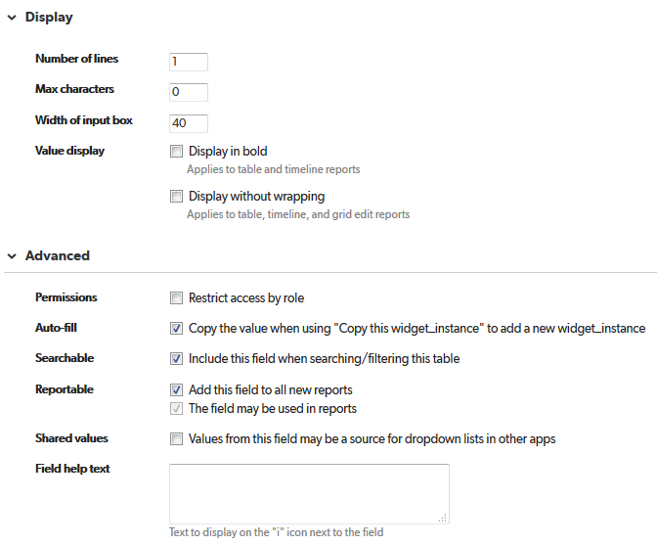

# widget – description

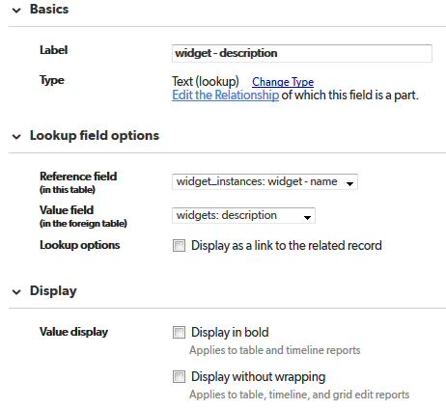

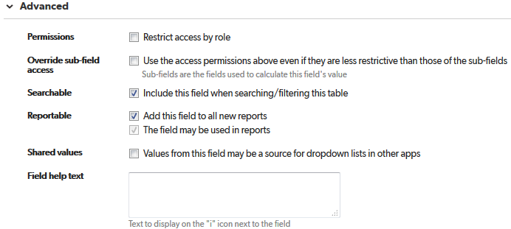

# files

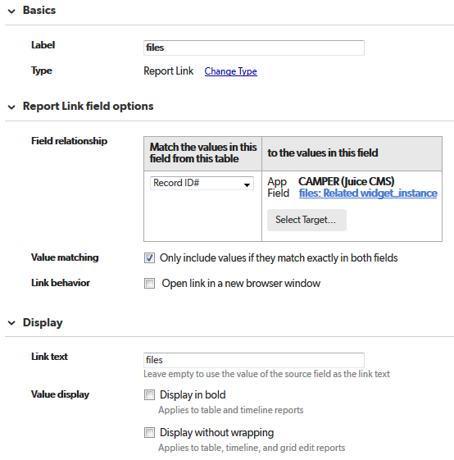

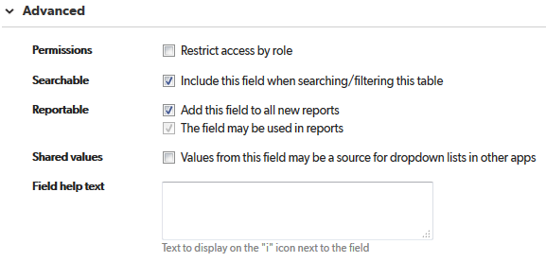

# New File

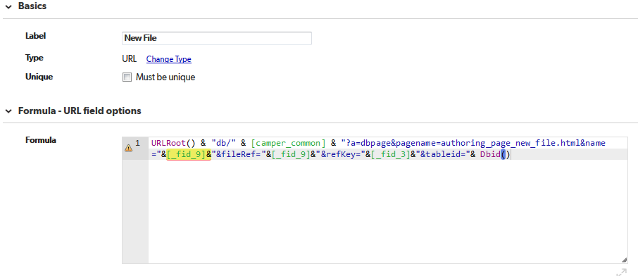

URLRoot() & "db/" & [camper_common] & "?a=dbpage&pagename=authoring_page_new_file.html&name="&[_fid_9]&"&fileRef="&[_fid_9]&"&refKey="&[_fid_3]&"&tableid="& Dbid()

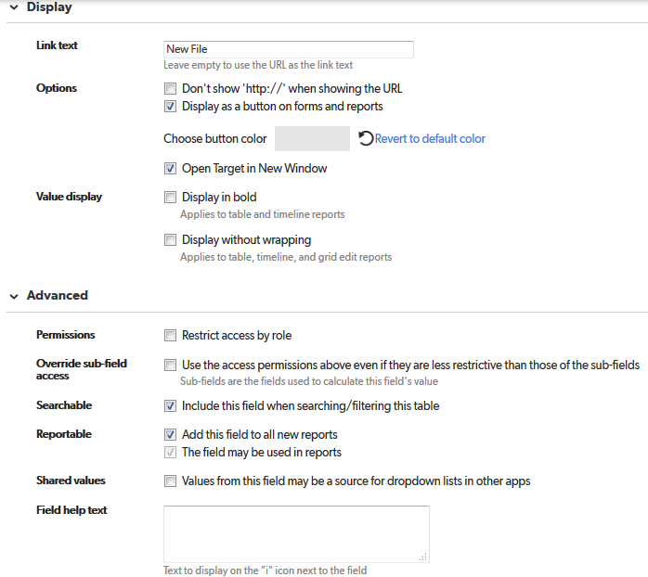

# Add file

Unused

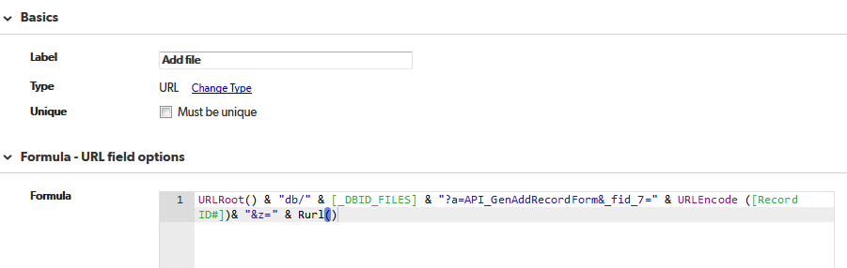

URLRoot() & "db/" & [_DBID_FILES] & "?a=API_GenAddRecordForm&_fid_7=" & URLEncode ([Record ID#])& "&z=" & Rurl()

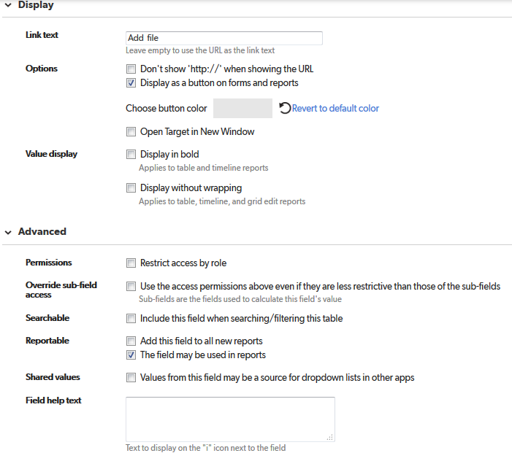

# files_list

JUICE currently supports only one file per widget instance

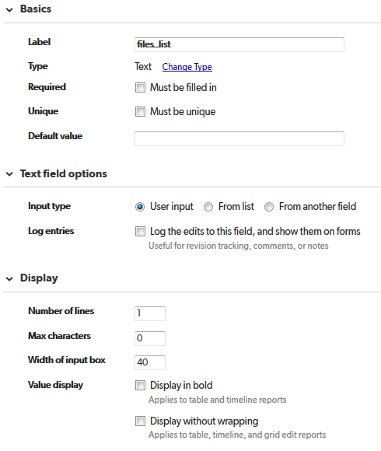

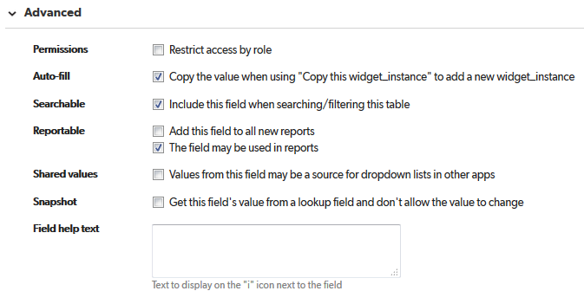

# instance_order

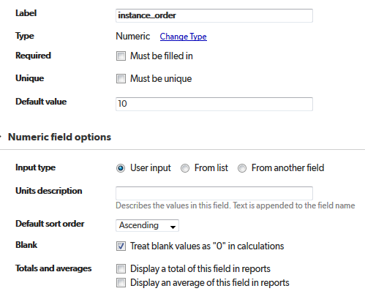

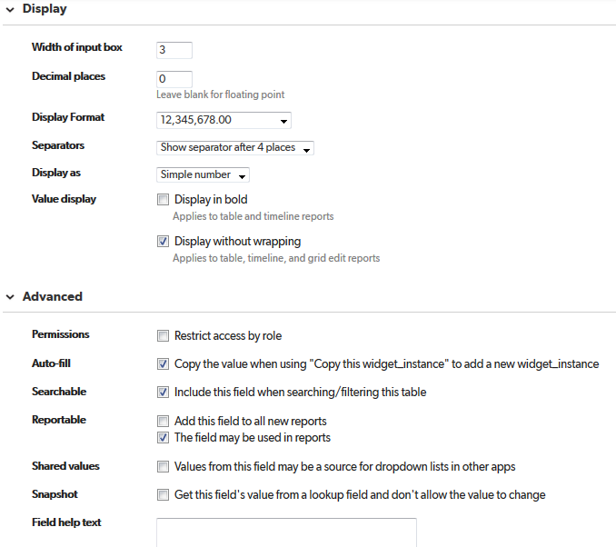

# Preview

Unused

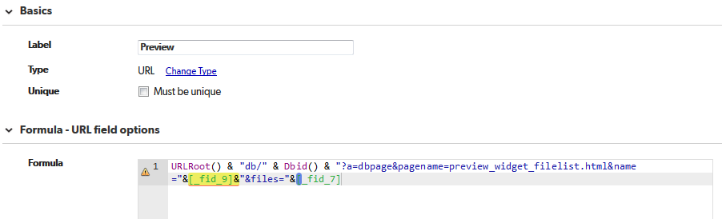

URLRoot() & "db/" & Dbid() & "?a=dbpage&pagename=preview_widget_filelist.html&name="&[_fid_9]&"&files="&[_fid_7]

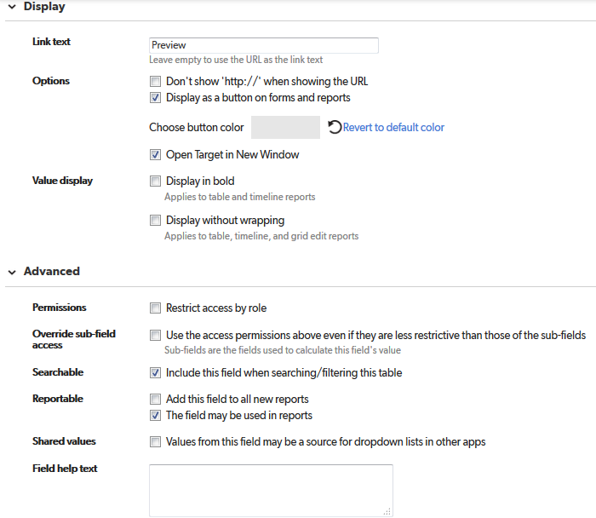

# Related track

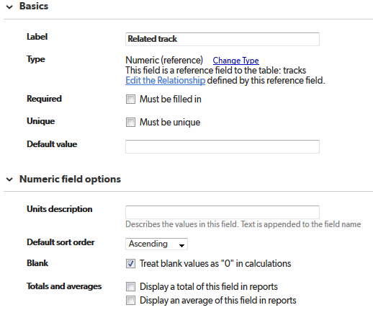

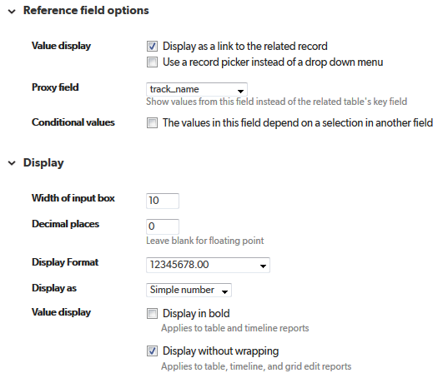

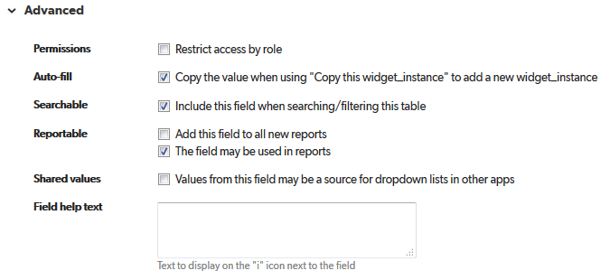

# Related widget

# 

# related_module_id

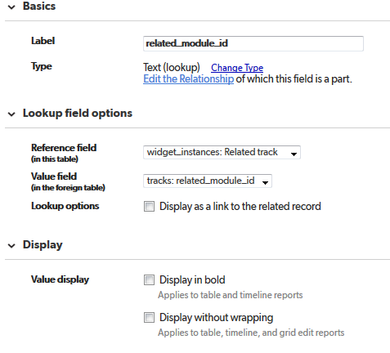

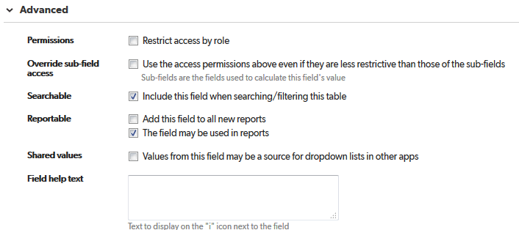

# sort_order

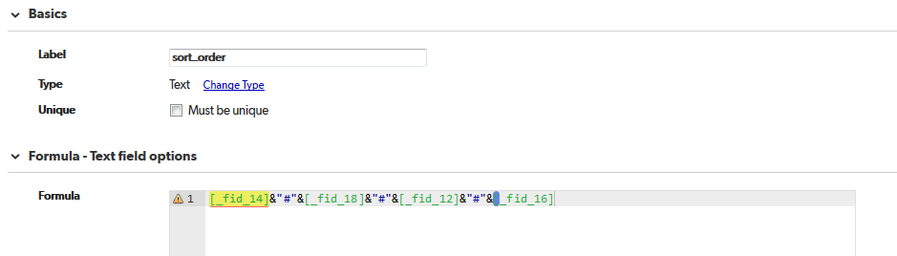

[_fid_14]&"#"&[_fid_18]&"#"&[_fid_12]&"#"&[_fid_16]

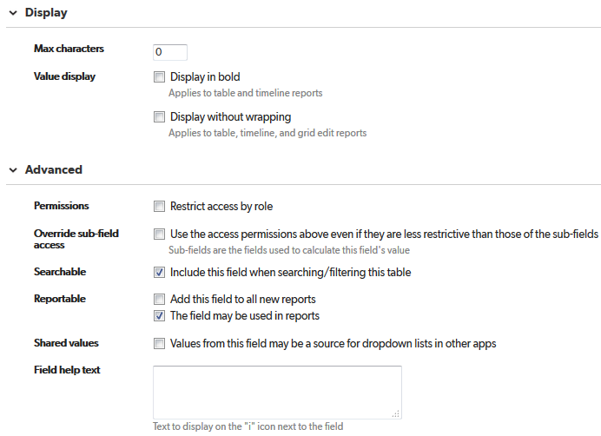

# track - Related tab

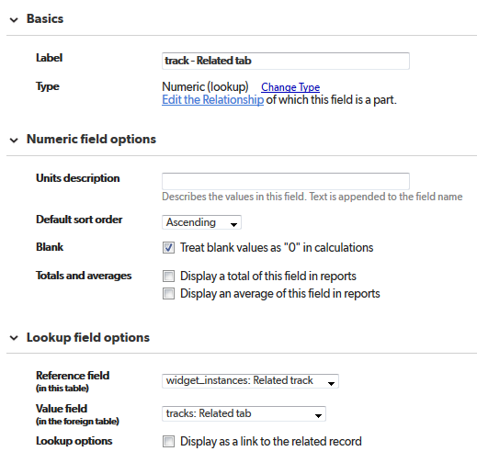

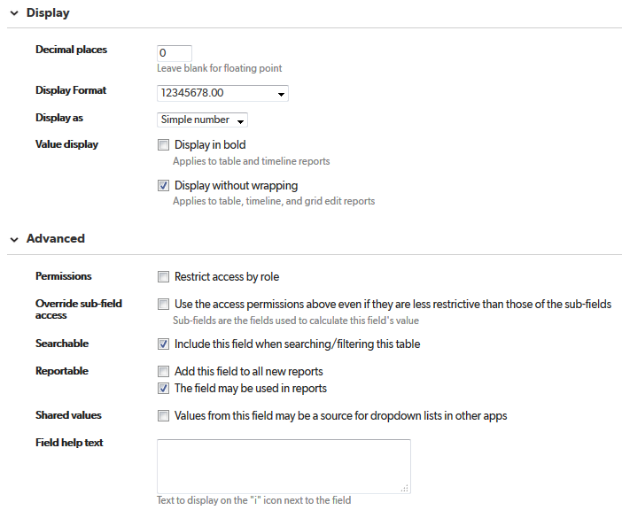

# track - tab - type

